# Restaurant’s Sales Data Dashboard

## This analysis provides key insights into McDonald's sales performance, item popularity, customer preferences, and time-based order trends based on the dataset. Below are the core findings and actionable insights based on the cleaning and transformation steps applied to the data.

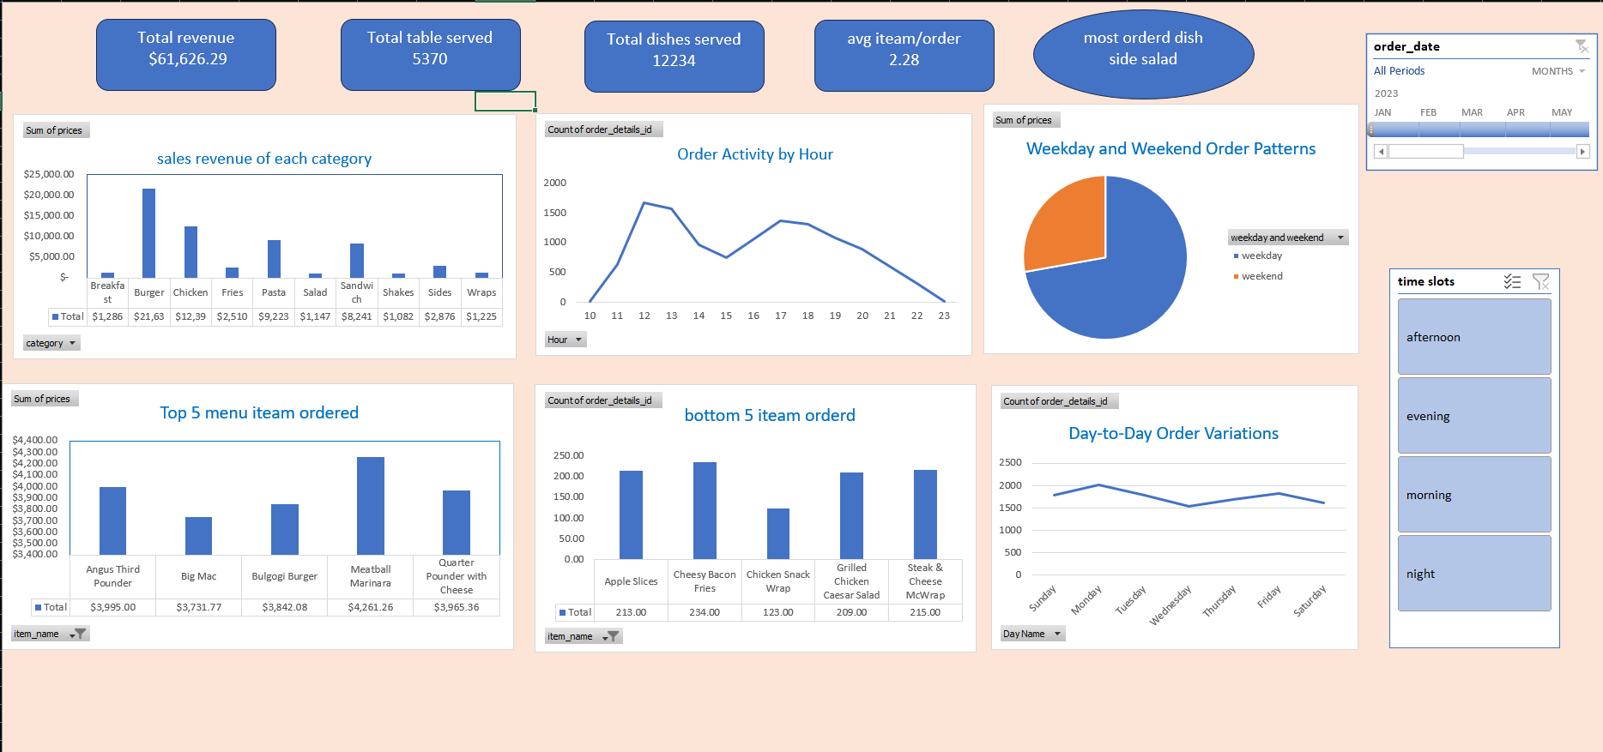

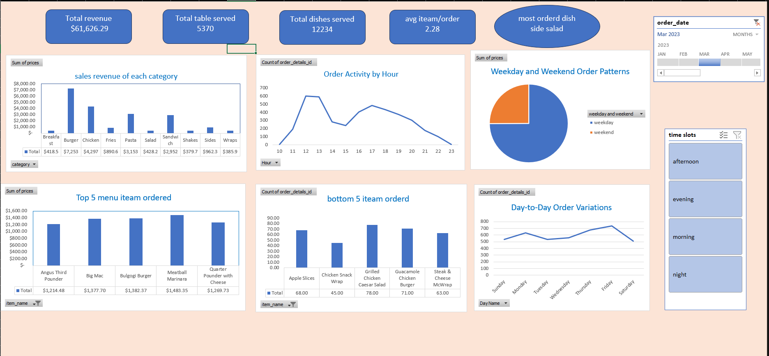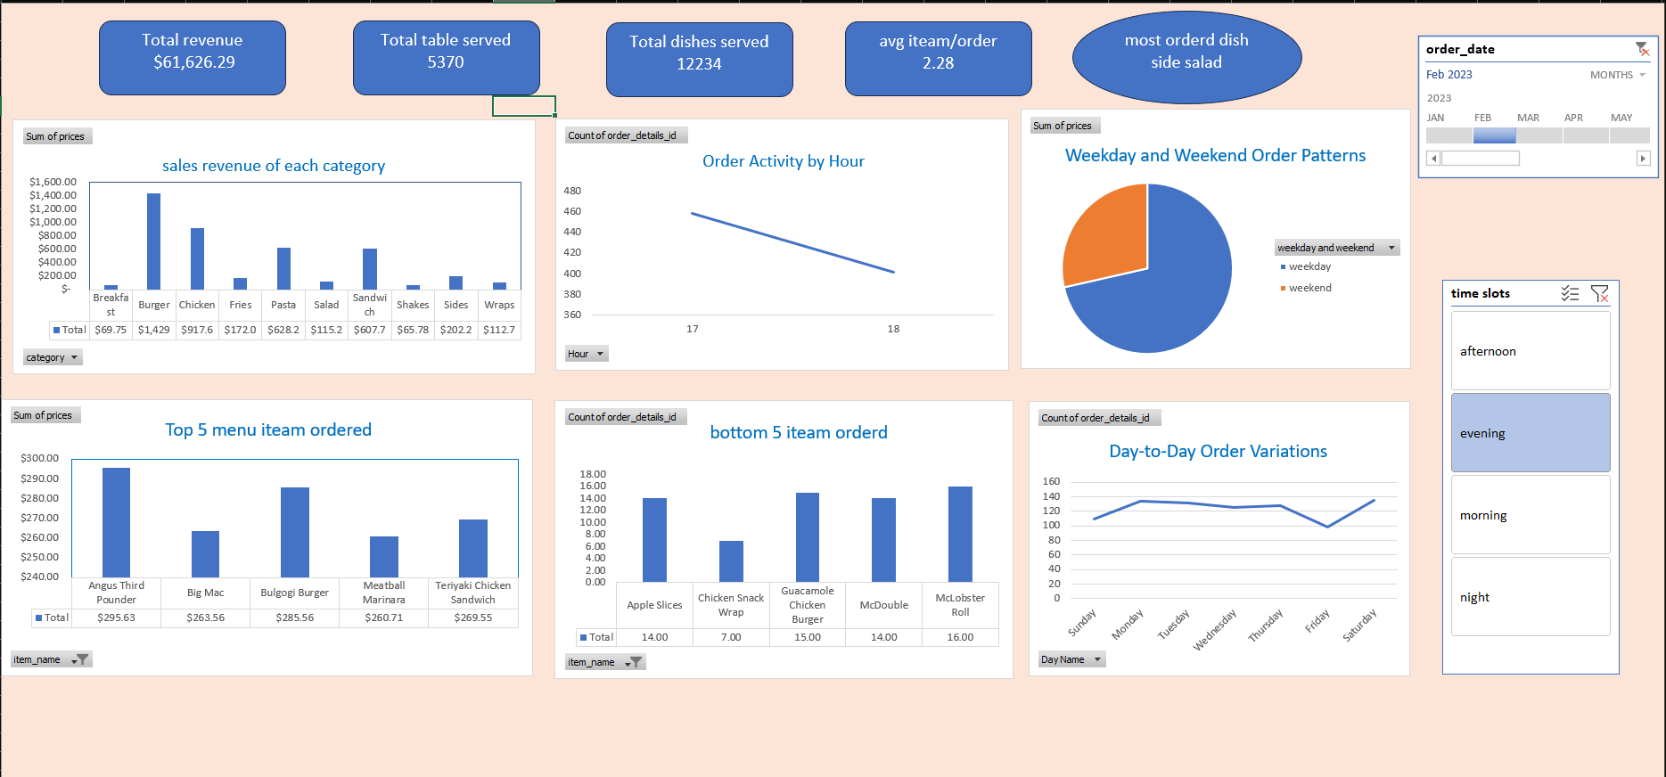

# Executive Summary of Restraunt’s Sales Data Dashboard

## This analysis provides key insights into McDonald's sales performance, item popularity, customer preferences, and time-based order trends based on the dataset. Below are the core findings and actionable insights based on the cleaning and transformation steps applied to the data.

## Key Insights:

### Total Revenue and Sales Performance:

### The total sales revenue is $61,626.29 across 5,370 tables served, with a total of 12,234 dishes.

### The average items per order is 2.28, indicating that customers typically order multiple items per transaction.

# Sales Revenue by Menu Category:

### Burgers generated the highest revenue, total $1,555, followed by chicken items at $1,021 and pasta at $714.1.

### Side dishes like fries contributed a significant portion of sales, with fries alone generating $203.2.

### Other items such as shakes and wraps had lower revenues compared to main meals, with $95.68 and $57.88 respectively.

# Top 5 Menu Items:

### The most popular menu items based on revenue were:

### Angus Third Pounder ($350)

### Big Mac ($300)

### Bulgogi Burger ($300)

### Meatball Marinara ($250)

### Teriyaki Chicken Sandwich ($200)

### Angus Third Pounder contributed the most, accounting for approximately 7.3% of the total sales.

# Least Popular Items:

### The bottom five items ordered include Cheesy Bacon Fries (16 orders), Chicken Snack Wrap (10 orders), and Steak & Cheese McWrap (7 orders).

### These items together contributed only a small percentage of total sales, signaling a potential need to re-evaluate their presence on the menu or promote them better.

# Time-Based Trends:

# Order Activity by Hour:

### Orders peak in the early evening (6-8 PM) and gradually decrease towards closing time.

## Day of the Week:

## Sales vary across the week, with Monday showing the highest number of orders, followed by Friday.

## Weekend vs. Weekday Trends:

### Weekday sales make up 60% of the total orders, while weekend orders contribute 40%, suggesting slightly busier weekdays.

# Order Time Variations:

### A breakdown of the time of day shows that most orders occur during the evening and afternoon time slots, contributing to 65% of daily orders.

### The night time slot (after 9 PM) has significantly fewer orders, representing less than 10% of total daily activity.

# Recommendations for Business Growth:

## Focus on Peak Times:

### Since the early evening is the busiest time for orders, increasing staff and offering promotional deals or combos during these hours could help boost sales.

### The data shows a significant drop in orders post-9 PM. Consider launching late-night specials or adjusting closing hours to reduce operational costs if the traffic remains low.

### Leverage Popular Items:

### Burgers and chicken items are major revenue drivers. Promoting these categories with upsell opportunities (e.g., adding fries and a drink combo) can increase the average order value.

### The Angus Third Pounder and Big Mac are highly popular—highlight these items in promotions or create limited-time offers around them.

## Improve Less Popular Items:

### Since some menu items like Cheesy Bacon Fries and Chicken Snack Wrap have low sales, try promoting them with discounts or bundle deals.

### Alternatively, consider removing underperforming items from the menu to streamline operations and focus on better-performing items.

## Increase Weekend Traffic:

### With weekdays being busier, there is an opportunity to boost weekend sales through targeted promotions (e.g., family meal deals or weekend-only specials).

## Seasonal and Monthly Adjustments:

### Evaluate sales performance over the months and seasons to introduce seasonal menu items or adjust marketing strategies based on the highest sales periods.

### By focusing on peak hours, promoting top-performing items, and optimizing the menu for better sales, McDonald's can enhance revenue and customer satisfaction.

## Percentage Highlights:

### 60% of sales occur on weekdays, while 40% occur on weekends.

### The Top 5 menu items contribute approximately 20-25% of total revenue.

### Evening orders make up 35% of daily sales, while night orders contribute less than 10%.